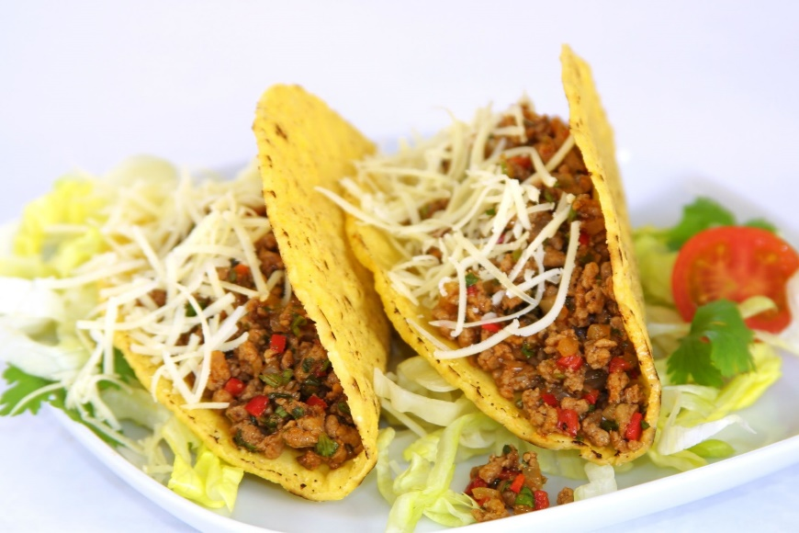

THURSDAY NIGHT

# TACO-MANIA 2024

by *“Smokin ‘n Style”*

At the Pavillion on Thursday night (6:30ish)

Soft or Crispy Tacos with Seasoned Beef, Chicken or Carne Asada plus all the ‘toppings’! Homemade Salsa, Queso & Chips

And THE BEST Ice Tea!

Send $9.50 **per person** to reserve your meal! Add this amount to your registration form, and *return* this page for your reservation.

Name______________________________________________________

Address____________________________________________________

**#** of Tickets ________ x $9.50 = $____________ (Amount Enclosed).