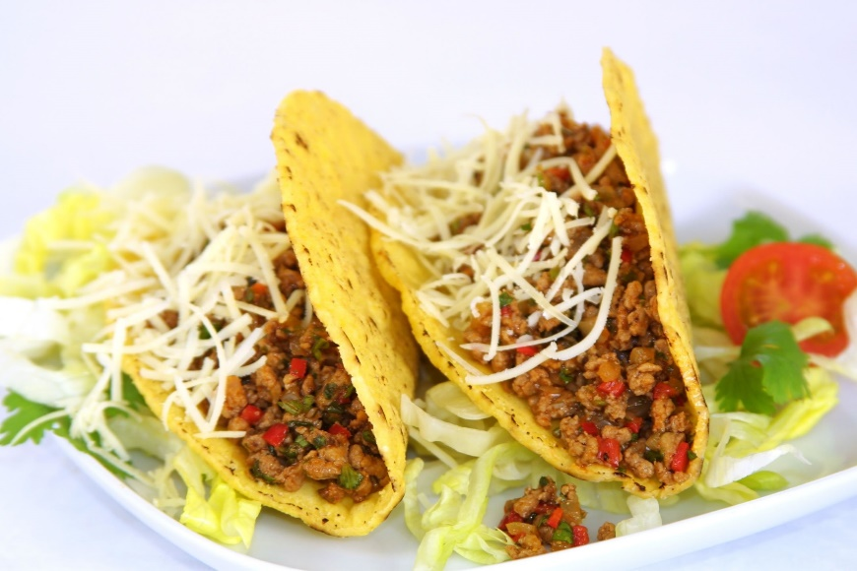

THURSDAY NIGHT

TACO-MANIA 2026
by “Smokin ‘n Style”

At the Pavillion on Thursday night (6:30ish)
Soft or Crispy Tacos with Seasoned Beef, Chicken or Carne Asada plus all the ‘toppings’! Homemade Salsa, Queso & Chips
And THE BEST Ice Tea!
Send $12.00 per person to reserve your meal! Add this amount to your registration form, and return this page for your reservation.

Name______________________________________________________

Address____________________________________________________

# of Tickets ________ x $12.00 = $____________ (Amount Enclosed).

